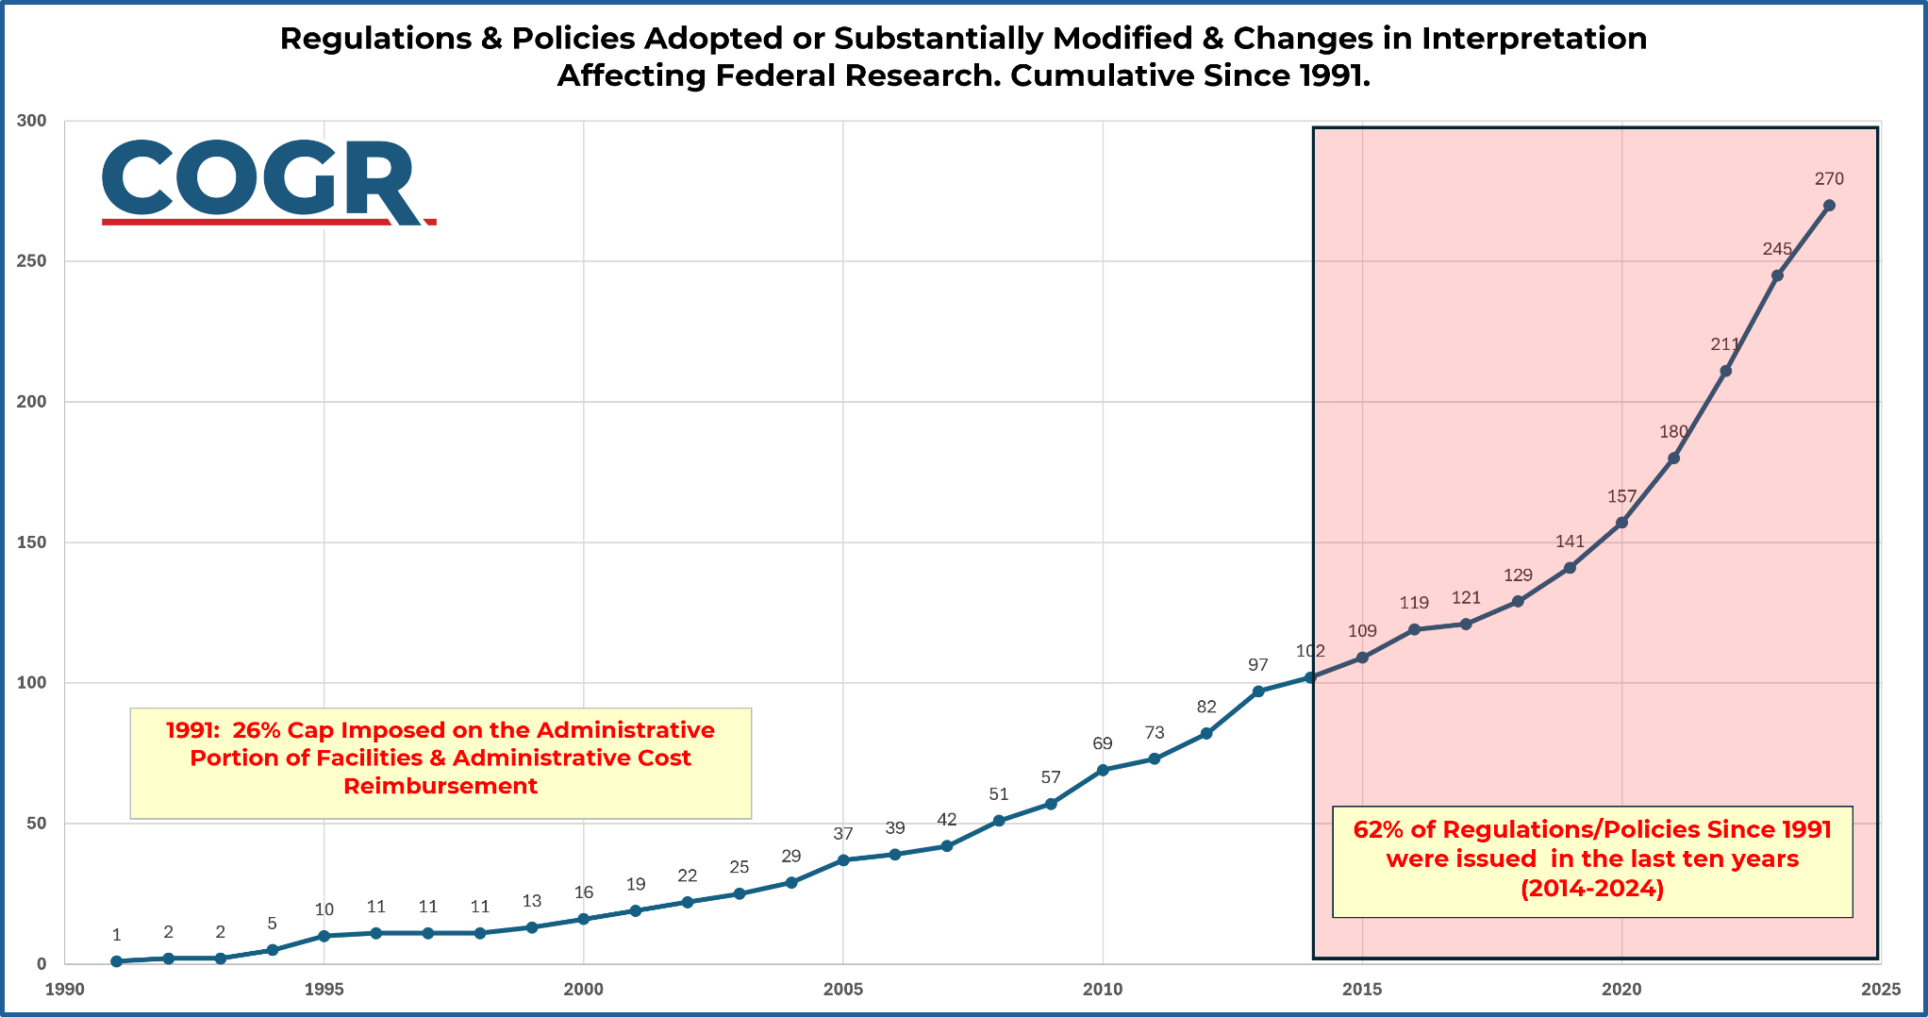

Figure 1. Regulations & Policies Adopted or Substantially Modified & Changes in Interpretation Affecting Federal Research. Cumulative Since 1991.

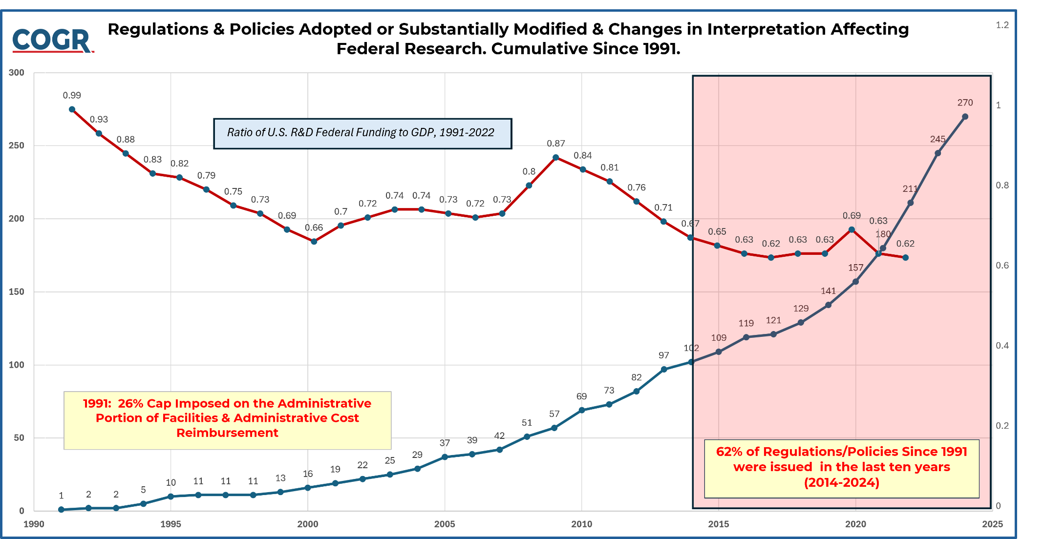

Figure 2. See Graph Download (Word Version). Figure 1 with GDP Overlay.

